COMPUTER LABORATORY

(Venue B 114)
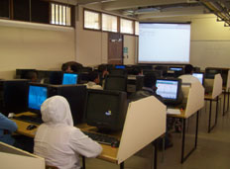

Software Design 2, Software Design 3, Process Control IV, Micrcontrollers IV and Computer Networks IV, Microsystems Design IV.

