PROJECTS TEST LAB (Venue B 110)

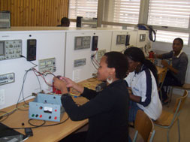

12 Test stations. Each test station has a Variac, multi meter, Oscilloscope, signal generator and variable dc supply. Projects 1, Electronic Porject Design 3, Industrial Project Design IV.

