ELECTRONIC COMMUNICATION LABORATORY

(Venue B 212)
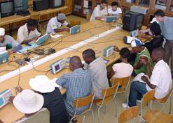
Building and Analysis of Communication and Radio Circuits. Radio 3, SatelliteIV, Electronic Communication IV, Microwave.

